Unit Test MapReduce using MRUnit

In order to make sure that your code is correct, you need to Unit test your code first. And like you unit test your Java code using JUnit testing framework, the same can be done using MRUnit to test MapReduce Jobs.
MRUnit is built on top of JUnit framework. So we will use the JUnit classes to implement unit test code for MapReduce. If you are familiar with JUnits then you will find unit testing for MapReduce jobs also follows the same pattern.
I will now discuss the template that can be used for writing any unit test for MapReduce job.
To Unit test MapReduce jobs:
- Create a new test class to the existing project
- Add the mrunit jar file to build path
- Declare the drivers
- Write a method for initializations & environment setup
- Write a method to test mapper
- Write a method to test reducer
- Write a method to test the whole MapReduce job
- Run the test

Create a new test class to the existing project
I’ll use the WordCount example to demonstrate unit testing. First create a new class with the name “TestWordCount” in the existing wordCount project.
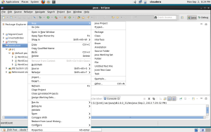
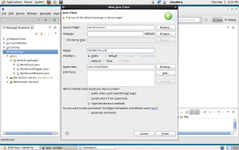

Add the mrunit jar file to build path
Download the latest mrunit jar file from http://apache.cs.utah.edu/mrunit/mrunit-1.0.0/. Unzip the folder and you will find mrunit jar file inside the lib directory. We need to add that jar to the build path.
Right click on the project and click on “Properties”.
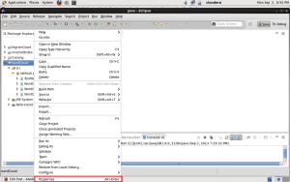
Click on Add external Jar file and add the jar file you recently downloaded.
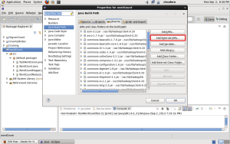

Declare the drivers
Instead of running the actual driver class, for unit testing we will declare drivers to test mapper, reducer and the whole MapReduce job.

1  2  3 | MapDriver<LongWritable, Text, Text, IntWritable> mapDriver;  ReduceDriver<Text, IntWritable, Text, IntWritable> reduceDriver;  MapReduceDriver<LongWritable, Text, Text, IntWritable, Text, IntWritable> mapReduceDriver;

Note that you need to import the following:

1  2  3 | import org.apache.hadoop.mrunit.mapreduce.MapDriver;  import org.apache.hadoop.mrunit.mapreduce.MapReduceDriver;  import org.apache.hadoop.mrunit.mapreduce.ReduceDriver;

and not

1  2  3 | import org.apache.hadoop.mrunit.MapDriver;  import org.apache.hadoop.mrunit.MapReduceDriver;  import org.apache.hadoop.mrunit.ReduceDriver;

As the word count mapper takes LongWritable offset and Text of line, we have given the same as the generic parameters of the mapDriver. Same is the case with the reduceDriver and mapReduceDriver.

Write a method for initializations & environment setup
This is the code that runs before any (and every) test runs and can be used for all the initializations that you want to do. You will need to add @Before annotation before this method.

1  2  3  4  5  6  7  8  9  10  11  12  13  14  15 | @Before  public void setUp()  {  WordCountMapper mapper = new WordCountMapper();  mapDriver = new MapDriver<LongWritable, Text, Text, IntWritable>();  mapDriver.setMapper(mapper);  WordCountReducer reducer = new WordCountReducer();  reduceDriver = new ReduceDriver<Text, IntWritable, Text, IntWritable>();  reduceDriver.setReducer(reducer);  mapReduceDriver = new MapReduceDriver<LongWritable, Text, Text, IntWritable, Text, IntWritable>();  mapReduceDriver.setMapper(mapper);  mapReduceDriver.setReducer(reducer);  }

In the first three lines of the above code, we create an object of the mapDriver and set the mapper for the driver. Note that we are not setting the reducer class. It is because the mapDriver will only test the mapper logic.
Similarly we set the reducer class to the reduceDriver. However, when we want to test the MapRedcue job as a whole, we need to test both the mapper and the reducer. Therefore we need to set both the mapper and reducer class to the mapReduceDriver.

Write a method to test mapper
To declare a method as a test method it must be annotated with @Test.

1  2  3  4  5  6  7  8  9 | @Test  public void testMapper() throws IOException  {  mapDriver.withInput(new LongWritable(1), new Text("orange orange apple"));  mapDriver.withOutput(new Text("orange"), new IntWritable(1));  mapDriver.withOutput(new Text("orange"), new IntWritable(1));  mapDriver.withOutput(new Text("apple"), new IntWritable(1));  mapDriver.runTest();  }

The mapDriver takes as input a LongWritable and a Text “apple orange orange” in the form of key value pair. We want out wordCountMapper to output each word as key and “1” as the value. So we set the output of the driver accordingly. Finally runTest method runs the mapDriver.

Write a method to test reducer
In the wordCount example, we get a word and list of IntWritable values (all 1’s) associated with it. The reducer code is then supposed to give the final ouput with word as key and its count as value. To test the reducer functionality we use the code given below.

1  2  3  4  5  6  7  8  9  10 | @Test  public void testReducer() throws IOException  {  List values = new ArrayList();  values.add(new IntWritable(1));  values.add(new IntWritable(1));  reduceDriver.withInput(new Text("orange"), values);  reduceDriver.withOutput(new Text("orange"), new IntWritable(2));  reduceDriver.runTest();  }

Write a method to test the whole MapReduce job
In order to test the complete MapReduce job, we give the input offset as key and line of text as value to the mapReduceDriver. And the final output is supposed to be the word as key and its count as the value. We therefore set addInput and addOutput appropriately.

1  2  3  4  5  6  7  8 | @Test  public void testMapperReducer() throws IOException  {  mapReduceDriver.addInput(new LongWritable(1), new Text("orange orange apple"));  mapReduceDriver.addOutput(new Text("orange"), new IntWritable(2));  mapReduceDriver.addOutput(new Text("apple"), new IntWritable(1));  mapReduceDriver.runTest();  }

Run the test
To run the test, right click on the class “TestWordCount” and goto “Run as” and select “Junit Test”.
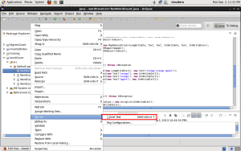
If the mapper, reducer and mapReduce job as a whole is correct, then you should get an output where you see no errors or failures.
